**“Voice In the Ear”**

**A Military First-Person Shooter Scenario**

**Writing Sample Background:** This was part of a short, timed writing test for a popular military FPS franchise that emphasized modern real-world scenarios. The characters’ voices tended to be terse and extremely mission-focused. I was given a broad outline – level concept, enemies, and an idea for a boss fight – and had to run with it using what I knew of special ops and the games about them. I have genericized the characters from the game. The mission goal – stop the communications from being compromised – was my invention.

**Game Summary:** The player’s organization is KILLSWITCH, a team of special forces operatives that are not sanctioned or acknowledged by the U.S. government. They find imminent threats to the homeland or its allies, eliminate terrorists, extract hostages, and cause a lot of property damage. The player, a former SAS major (“Officer Commander”) named JAMES BYRNE, reports to LIANA JIANG, an off-the-books CIA operative who secures logistics and intelligence to aim Killswitch at the worst elements of the international underworld. The enemy faction in this game is AL-ZALAAM, an organization from the fictional Central Asian country of Khodastan. They have raided a Swiss lab and acquired self-replicating nanite material that corrodes steel. In the first few missions, Al-Zalaam used the material to collapse buildings and neutralize ambulance fleets attempting to help. They grant no mercy, nor expect any.

**Mission Summary:** Al-Zalaam West Africa are hacking into Killswitch’s communications. The player’s team assaults a compound near a fishing village in Nigeria to retrieve a countermeasure. During the mission, they get false orders from an enemy imitating Jiang, and must face down a main battle tank to evacuate.

**Design Notes Part 1: The Village**

After the initial briefing establishes that his communications will be compromised, Byrne and three NPCs (local ally Musa, and two new Killswitch soldiers: Vegas and Ocampo) approach an isolated village in Nigeria at night, by land, using night vision. The village is on a peninsula, a maze of wood-and-sheet-metal shanty-town structures near the water. A central road leads to a command post; beyond that, a bridge leads to a fortified compound, the ultimate target. There are about 18 guards in the village, 12 on the bridge.

If the player goes straight into the center of town, it’s rough. There are more guards, more light for the guards to see by, and frequent corners that conceal multiple enemies, practically guaranteeing an alert. Anyone in the central square (a roundabout in the road) can be seen and hit from all sides.

If the player swings north, the paths are frequently blocked, but ladders, vehicles, and stacked crates mean they can climb to the rooftops, giving them better fields of fire. One particular tower has AZs with sniper rifles and RPGs. If the player takes it over, they can rain down destruction and cover their team.

If the player goes to the southern side, there are fewer guards, and many docks and water, allowing the player to more easily lose pursuit and ambush enemies. Note the shanties have kerosene lanterns, not electric lights; the command post is called out in dialogue because its power supply is visible.

**Design Notes Part 2: The Bridge**When the player secures the command post, AZ’s alert goes up if it hasn’t already, and AZ’s hacker patches into Byrne’s communications to try to confuse the team. The player fights the enemies on the bridge. It’s a chokepoint. Players might try swimming, but the far side is bare concrete, too steep to climb. The equalizer for getting across the bridge is interacting with one of the stopped cars: by putting it in neutral; the team can shove it ahead of them to use the car body to provide cover from small arms as they advance. On the far side of the bridge is a mountainous area with the main AZ compound.

**Design Notes Part 3: The Tank Boss Fight**

The player clears the compound’s main building, takes out the source of the bogus orders, and signals for the helo to evacuate. But AZ has rallied with a main battle tank. The evac helo would be a sitting duck for the tank’s main gun if it tried to land. The tank sees in infrared, and its heavy machine gun cuts through cover and personal armor like paper. Simply running away down the bridge won’t work – the bridge has no inherent cover that can stop the tank’s weapons. The player can drop thermal smoke, which conceals anyone in it (the tank’s fire becomes inaccurate, though the bridge remains a kill zone).

The team needs to evade the tank’s fire, grab the enemy’s leftover RPGs, and take out the tank. (To avoid a mission failure due to an ammo shortage, there is an AZ armory where the player can fetch RPGs one at a time.) The tank’s reactive armor means it needs repeated hits in the same spot to penetrate. Destroying its treads makes a kill shot much easier. Lastly, there’s an achievement option: if Byrne can, without dying, lure the tank onto the bridge, an RPG shot from underneath will use the tank’s weight to collapse it. Once the tank is defeated, the helicopter can land, and the team successfully evacuates.

**Player-Facing Content**

**The Briefing:** Jiang and Byrne meet on a tarmac in Abuja, Nigeria.

BYRNE: Sykes is still in hospital? It’s not like him to get caught unprepared.  
JIANG: It was targeted disinformation. He got bogus orders that sounded real. Military-grade deepfake in action.  
BYRNE: Still would require some kind of data breach. By someone who knows Killswitch exists.  
JIANG: (nods) Al-Zalaam’s stepped up their cyber game. They have a novel cryptographic attack, called *Gaibu*. It’s been quietly listening to US traffic, building fakes to cause confusion on the ground.  
JIANG: We need an intact copy of *Gaibu* to develop a counter. Lieutenant Musa of the Nigerian Army is helping us get that copy. He’ll take you to an Al-Zalaam West Africa compound up the Niger river.  
BYRNE: Civilian presence?  
JIANG: AZWA isolates their recruits for better indoctrination. The compound and the village next to it are entirely their people. So, don’t worry about blending in. You can do things your way.  
BYRNE: Don’t think I won’t. On the worst day of my life, Sykes talked me out of... something stupid.  
JIANG: Do I want to know what that was?  
BYRNE: There’s things only he and I get to know. Point is, I’ll give AZ what for.  
JIANG: Be warned: if they get wind of you, they’ll use *Gaibu*. Assume all radio comms are compromised. So, I’ll go dark, and you get free reign. Ignore anything that sounds like me.  
BYRNE: I’d make an easy joke here, but I’m more concerned with how we exfil without radio.  
JIANG: The helo will have eyes on. Send up a flare, then designate the LZ with thermal smoke. And I can’t emphasize enough to ignore communications. If Sykes hadn’t lived, we’d still be in the dark about their dirty trick.  
BYRNE: Understood. When you see Sykes again… tell him I’ll make it count.

**When the player begins their approach toward the village:**BYRNE: Stay close. Verbal range.  
MUSA: I copy. Village is just ahead.  
**If an alert goes up:**AL-ZALAAM (Subtitle: We are being attacked!):Mu ne ana kai hari!  
MUSA: They’re alerted! Go, go, go!  
**When the player has pushed to the AZ command post by the bridge:**VEGAS: This building’s got power. Jiang’s tech toy could be inside. Byrne, take point.  
**When the player finds secondary intel on the command post’s top floor:**   
MUSA: No serious computing power here. But this looks like a membership list.  
BYRNE: Grab and go.  
**When the bridge outside lights up (this is triggered by finding the intel):**BYRNE: We’ve been made.  
“JIANG” (RADIO): Killswitch, this is Jiang. Abort and hold your position, we have birds in the sky coming to evac you.  
BYRNE: Aren’t you cute? That’s not her. We need to get out of this death trap now.  
**When the player exits the command post after finding the intel and (scripted event) a rocket-propelled grenade hits the top floor where they just were:**VEGAS: God DAMN!  
BYRNE: That bogus communication shite is real!  
OCAMPO: RPG!  
**When the player takes out the first rank of bridge soldiers (i.e., there’s a pause in the fighting):**“JIANG” (RADIO): Hostiles inbound behind you! Get out of there, please! There’s no way to survive!  
BYRNE: Jiang’s never said ‘please’ in her life. Take the bridge.  
**As the player reaches the far side of the bridge, the last remaining AZ break and run for the mountain compound. Byrne breaches the door.**BYRNE: Musa, with me. You two, watch our six.  
**When Byrne and Musa search the main building and find a programmer with a microphone setup, using Gaibu:**PROGRAMMER: I say again, pull out. Evacuate--  
“JIANG” (ON RADIO): I say again, pull out. Evacuate--  
BYRNE: That’s our tango!  
**When the player has dispatched the programmer, Musa takes a DSM/USB drive:**MUSA: This is *Gaibu*. Time to fly.  
**When Byrne and Musa meet up with Vegas and Ocampo back at the main building entrance:**BYRNE:Tango acquired. Pop some light.  
**Vegas fires a flare, which lights up the compound. The camera turns to a main battle tank that starts its engine:**VEGAS: That was *not* in the briefing.  
OCAMPO: A VT-4! They’ve got thermal imaging!  
BYRNE: Scatter! Cover’s useless! Grab RPGs! **When the tank opens fire with its heavy machine gun:**BYRNE: Keep moving! That MG will cut through cover!

**When an NPC throws thermal smoke (1 line, dependent on speaker):**  
MUSA: Hot smoke! Hide in it!  
OCAMPO: The smoke! Confuse its infrared!   
VEGAS: Use the thermal for cover!  
**After about one minute of battle the evac chopper is in the air, HIGH above:**VEGAS: Will that chopper *ever* give air support?  
BYRNE: Tank’s main gun would take out the helo. Stick and move!  
**If the player hits one of the tank’s treads with an RPG:**  
BYRNE: Chase me now, wanker.  
**If the player hits a second tread with RPGs, immobilizing it:**  
BYRNE: Now for the kill shots.  
**If the player hits the tank in an armored area:**  
BYRNE: Bloody reactive armor. Hit it again, same spot!  
**If the player runs onto the bridge:**  
VEGAS: That bridge is a kill zone!  
BYRNE: Yeah, for it and me!  
**If the player kills the tank with an RPG hit:**  
BYRNE: My mate Sykes says hello.  
**If the player kills the tank by blowing out the bridge underneath it:**BYRNE: Can you swim, you bollocks?  
**As the evac helicopter comes in to land:**BYRNE: Finally. Let’s cadge ourselves a ride.

**ART REFERENCES**

A basic map to give the idea of gameplay flow.

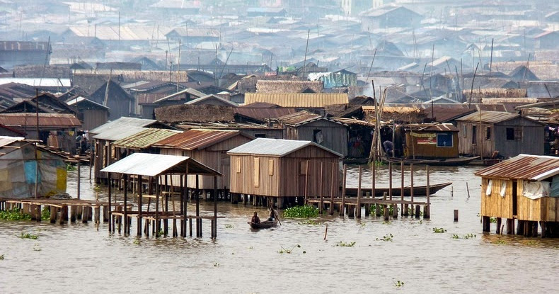  
South side of the fishing village taken over by Al-Zalaam.

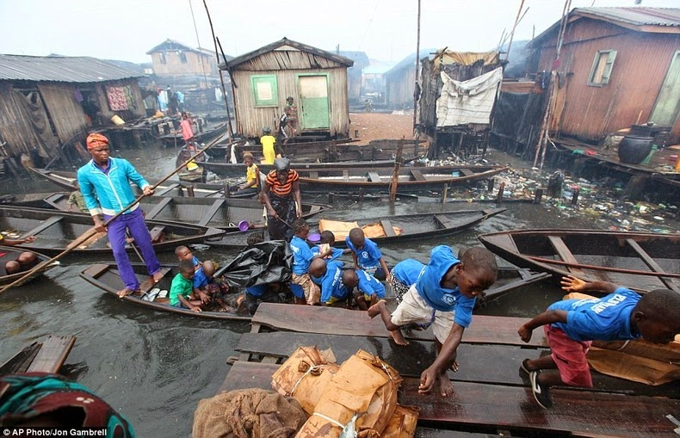

The player can hide in the water to evade pursuit and walk from boat to boat to get around.

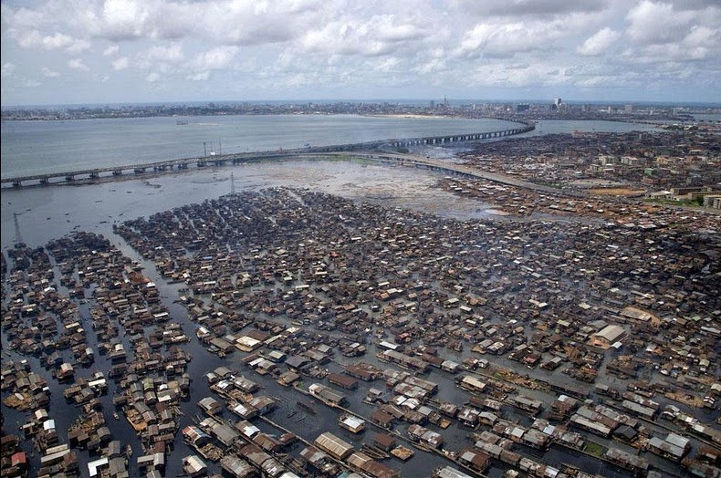

A road leads to the bridge (note that the bridge and road are probably much smaller scale in the level.) The road is solid enough to support heavy vehicles – not all of the village is on the water.

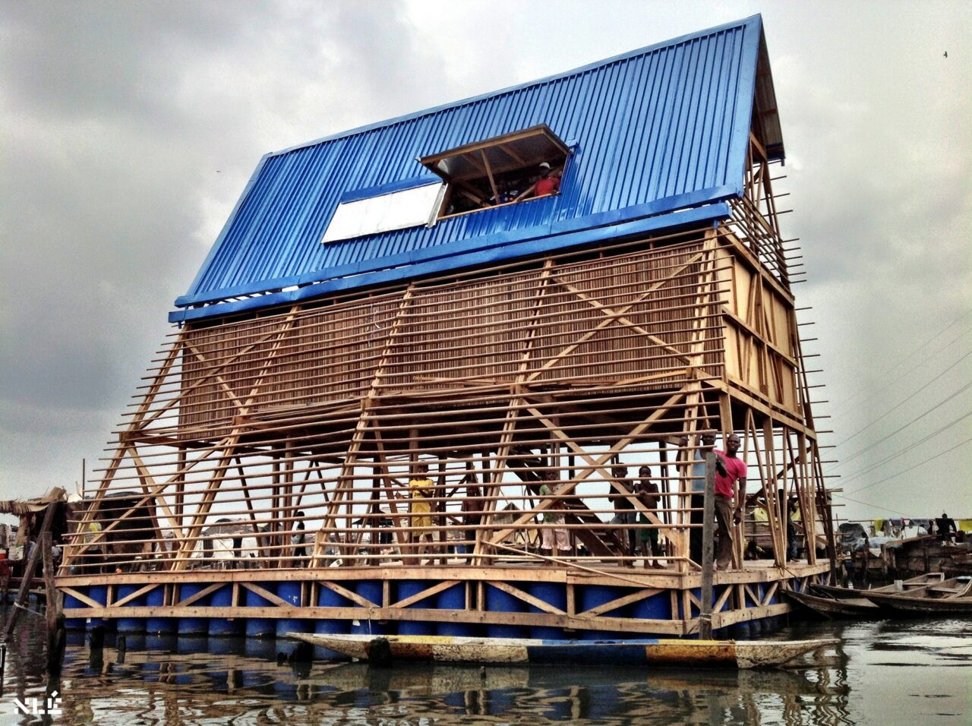

The tower used for sniping and RPG fire in the northern section.

The bridge is like this, but smaller. It’s tough enough (undamaged) to support a tank. A sneaky player could snipe guards from the water, but it’s hard to get clean shots and they’ll have to traverse the bridge anyway. If the tank is in pursuit, jumping to the water and hitting it from below with an RPG works great.

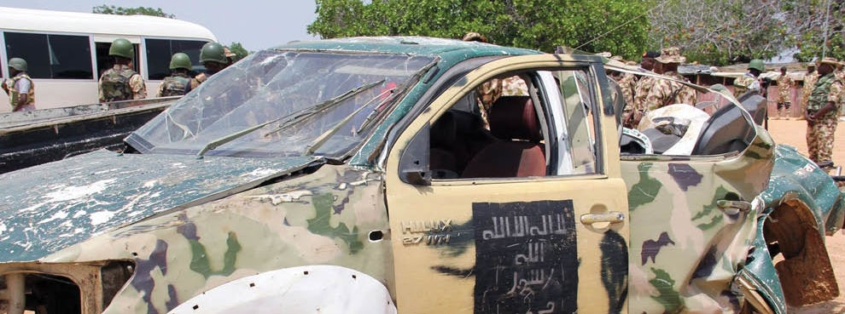

Vehicles used to provide improvisational cover when storming the bridge. (Artists should be sure not to copy the insignia exactly, we don’t know what it says.) I didn’t specify dialogue for moving the vehicle because a) it didn’t fit and b) it’d just be a popup option (“F to put in neutral”) and a grunt if the player walks into the back of the truck, pushing it forward.

The mountainous area has a compound with a wall and gate. It’s probably in better shape than this. Note that it should have an entrance wide enough to admit the tank.

The main building of the compound inside (minus the civilians).

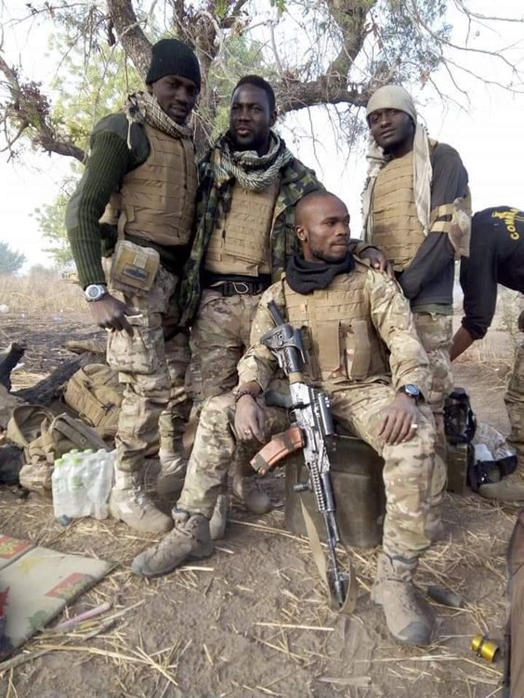

Nigerian army special forces to be used as a model for Lieutenant Musa. Nigeria’s national language is English, though most speakers like Musa have a regional accent. Signage would probably be in English and Hausa, which is why Musa goes inside buildings with Byrne – he can identify things when ransacking computers and such.

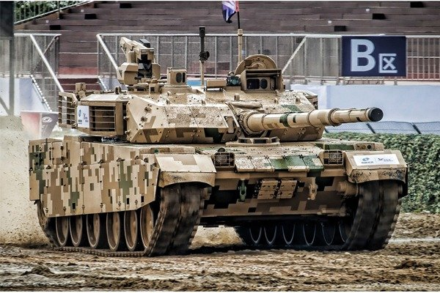

This is a Chinese-made VT-4 main battle tank (with thermal imaging tech) sold to the Nigerian Army. Boko Haram has captured Nigerian Army tanks before, so I thought it appropriate for a boss battle. The notch next to the main gun is where the coaxial heavy machine gun is. In real life, the gun’s muzzle flash is hidden, but in a video game, we’ll want some visual indication the gun is firing (muzzle flash, tracer rounds, etc.) so the player can dodge. In a real-life army unit expecting a battle, there’d be infantry backing the tank up to spot and kill ground troops like the player, but…

1. The player is unexpected and the opposition is scrambling to respond.
2. Fighting a tank that can basically “one-shot” you is already a nightmare in most players’ minds.
3. The player may have ground troops pursuing them from the previous stage already.
4. This writing sample is meant to answer the question “what if the boss battle was a tank?” and there is little need to complicate matters further.

The tank *probably* won’t use its main gun on human targets. Tanks don’t really do that as a rule, especially when the shots could destroy their own outpost. More practically, combat, art, and design departments would have to create lots of destructible buildings, and a 12.7mm (.50 caliber) machine gun that can see through and shoot through most walls is incredibly deadly already. *However…* if we’re talking “AAA game showpiece budget,” distracting the tank by rolling a vehicle from the bridge toward it could be an option. The tank would then hit the vehicle with its main gun. It’s not super *wise* of the tank gunner to do so, since their organization needs the bridge intact, but the players’ satisfaction at luring the tank onto the bridge by using cars as bait will probably outstrip such considerations.  
  
END OF DOCUMENT  
Thanks for reading!